*Abstract*— The “*Aarogya Patrika*” App is a unique solution which digitally links the three government frontline health workers in each village. These are the ANM (a nurse-midwife), the ASHA (community mobiliser) and the Anganwadi worker (overseer of nutrition in pregnant and lactating women, and pre-school children). These three women are responsible for providing health and nutrition services to the last-mile community across villages in India. Though they serve the same population, they don’t team up naturally because of different supervisory systems, databases and work cultures. Further, they are expected to maintain numerous voluminous registers. They can improve effectiveness and efficiency by sharing data and the app enables this in a seamless manner. The App enables the frontline workers to utilize a common database, carry out their routine tasks with ease and maintain integrity of data. It also generates essential government reports, provides an online supervision dashboard and enables referrals. While some technology solutions for frontline workers exist, none bring them together. Through all this, the workers can focus on their primary responsibility of delivering care, aided by data.

Keywords— Asha, Aarogya Patrika, CHW, Anganwadi, healthcare, Vaccines.

# Introduction

ASHA Accredited Social Health Activists workers are helping to build a strong foundation for promoting healthy practices in our society. They play critical role for various health programs of the Government of India. Accredited social health activists (ASHAs) can prevent many of these deaths by helping women and their families recognize maternal and neonatal danger signs and promptly seek care. However, a majority of ASHAs are low-literate village women, and they face significant operational challenges in conducting routine maternal, new-born, and child health (MNCH) activities and in keeping their skills updated. In particular, ASHAs' lack of access to health care information, refresher training, supportive supervision, and user-friendly job aids compromise their ability to contribute to improved maternal and new-born health outcomes.

Basically, ASHAs workers take surveys across different areas and collect information of families and on analysis they provide different Government Yojanas, financial aids and facilities to the eligible families. Currently, the information is collected on paper and data entry is done manually into excel sheets. This is time consuming and tedious procedure. Also, it becomes difficult to analyze these family’s data and take necessary actions. So, we proposed an app “Aarogya Patrika” which digitalizes whole process of data collection and analysis.

Social development of a nation is dependent on the health of its population. The impact of ASHAs on their communities is largely dependent on the quality of their training and other health system factors. Currently there is inadequate health system support for ASHAs including a lack of strong supervision, limited opportunities for continuing education and training and poor workload management. They get limited training on community mobilization, child immunization and others due to which they have limited knowledge and skills. Empowering ASHAs with “Aarogya Patrika” will help them to overcome the barrier

# Related Work

**N. D. Valakunde**, describes a system which is used in Uttar Pradesh state to monitor pregnant women in unprivileged parts of the country. The project is expected to reduce the maternal mortality rate by digitizing the work of the health workers by enabling them to monitor the pregnancies of the women in their area with the help of smartphones, effectively and efficiently. The Smart ASHA application is developed in Android Studio framework. The server is deployed on blazer pro using apache-HTTP Server and tables storing the data are implemented in phpMyAdmin-MySQL.

**R. V. Vaidya and D. K. Trivedi**, describes a system which can Track their fitness, Schedule appointments with a Doctor, set a reminder for themselves to take medicines on time and can request blood from a nearby donor in case of emergency and they can inform their relatives about current location. This system is implemented using Android Studio, Firebase, PHP and MySQL.

**Bhatia, Kavita**, describes that by equipping each and every ASHA worker in India with UPASANA, they can provide cheap quality healthcare to the people in rural areas. Upasana is a non-invasive medical diagnostic toolkit designed to be used by ASHA workers so that they can measure the vital parameters of the patients in rural areas and transfer the data to the doctors at the hospital for diagnosis.

# Problem Description

To maintain the security and integrity of “Aarogya Patrika”, the system will cater to two user groups viz. CHW Admin panel and Aarogya Patrika app. The activity flow of “Aarogya Patrika” is shown in Fig. 1.

## Aarogya Patrika App

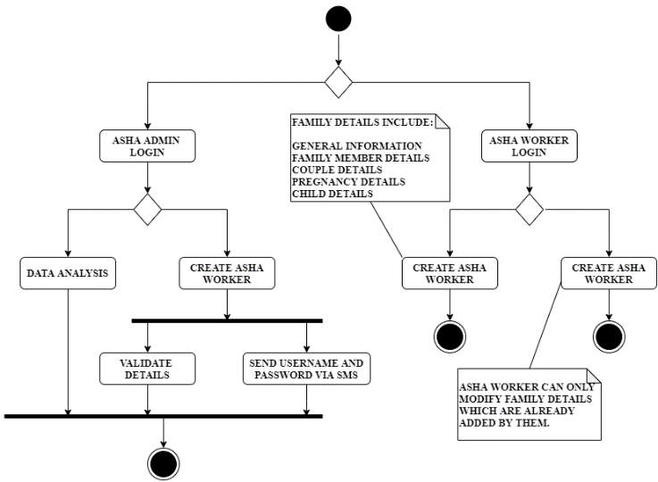ASHAs worker login to the App then they can either Add new Family Details or Modify existing family details. They can only modify the details of those families whose details are added by the particular ASHA worker. This helps in maintaining confidentiality and integrity of the app. For adding new family detail ASHAs need to enter data into 5 stages:

* GENERAL INFORMATION: General Information consists of common details of families like whether the family is having “**Kachha**” or “**Pakka**” House, is there any toilet facility in family’s house, do family belongs to below poverty line, type of water supply, caste and village name from where the family belongs.
* MEMBER INFORMATION: Family Member Information consists of member name, age, gender, mobile number (optional), Bank name (optional), Bank IFSC Code (optional), Account number (optional), family member having some kind of disease, disability and whether family member is undergoing from some treatment.
* COUPLE INFORMATION: Couple Information consists of Husband Name, Wife Name, Couple ID, currently using family planning method, total male children, total female children, gender of last child and number of child/children.
* PREGNANCY INFORMATION: Pregnancy Information consists of Mother Name, Para (Number of times women is pregnant. If this count is equal to or greater than 3 then it is denoted as high risk and then ASHAs insist them to you family planning method), last menstrual period, expected date of delivery, expected place of delivery, applied to JSY scheme (This is only available if family belongs to SC/ST caste) and applied to PMMVY scheme (This scheme is only available if women got pregnant for first time).
* CHILD INFORMATION: Child Information consists of Child name, Mother Name, Father Name, date of OPV / B2VIT / BCG / OPV1_IPV1_Penta1_Rota1 / OPV_2_Penta_2_Rota_2/OPV3_IPV2_Penta3_Rota3 / MR1_VitA1 / DPTB_QPVB_MR2_Vita2 and Child RCH ID.

## CHW Admin panel

On other end, CHW can only have access to admin panel. CHW admin can either do the analysis of family details where they can see the statistics of family whose houses is either “Kachha” or “Pakka”, how many couples are using family planning methods, etc. Or CHW can create ASHA Workers account which is needed to have access to the App. Web Server provides all the website features (Login, Creating ASHA Workers, Web Dashboard, view family details, Analytics) to admin who is CHW. CHW also have access to the whole app features. ASHA Workers are created in admin panel and they have only access to App. Where ASHA Workers need to login to the app to access all the other features. After logging in, they can add family details which includes general information, family member details, couple details, pregnancy details and child details. ASHA workers need to compulsory add these details and ASHA worker can also view family details and they also they have option to update family details.

1. Activity Diagram for Aarogya Patrika

# System Design

The software architecture is comprised of the database, server and the client application as shown in Fig. 2. MongoDB is used as a database which manages the data in form of nodes and relations. We have used NoSQL database which stores all the data in unstructured format.

The android application provides an efficient user interface for all ASHA workers for survey data entry. The mobile application Aauthentication and Aauthorization is done using AWS Cognito Service. The mobile application communicates with the database with the help of GraphQL API which provides efficient querying in low bandwidth areas.

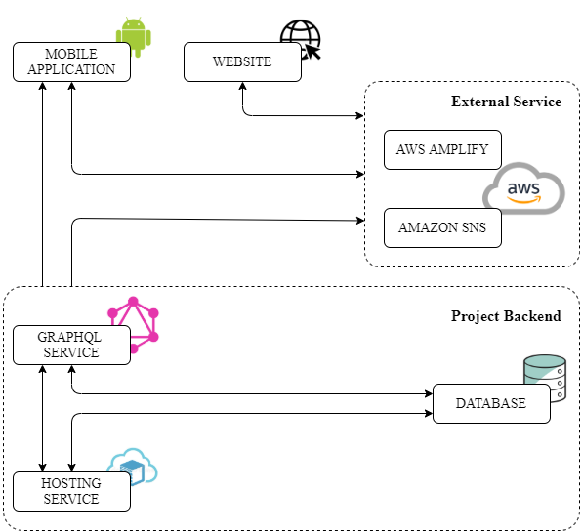

1. System Architecture for Aarogya Patrika

A Node.js web application (Admin Panel) is used for data visualization and analysis. MongoDB Aggregation Framework is used for data preprocessing and filtering for visualization. New ASHA workers are created from the admin panel and generated credentials are sent to asha workers using Amazon SNS (Simple Notification Service) service.

The server is deployed on Amazon EC2 as it is robust, free and easy to deploy. The basic hardware requirement for the system is any device having access to the internet connection which can run the “Aarogya Patrika” app and a server to store the database and host the Smart ASHA website.

# Conclusion

In today information era people need information even on the move. The relatively low-cost mobile wireless communication, creative thinking and thrust for information on the move laid down the foundation mobile applications. The only industry which is growing continuously in the last few years is the mobile application industry. Considering the penetration, utilization and benefits of mobile applications, it can be extended to empower the ASHA workers. Design and deployment of the “Aarogya Patrika” mobile application in multiple regional languages will improve the implementation of health-related programs initiated by government of India through ASHA workers. Based on health-related data collection and analysis by “Aarogya Patrika”, the requirement for medical solutions such as vaccines, medical kits etc. can also be optimized. As the data is collected over a period of time, the future prediction of drugs, medical facilities, equipment etc. for existing as well as new diseases is also possible. This will benefit the ASHA workers, society and country at large.